

**Customer manual**

**Project**

**“Pondok Daun” website**

Table of Contents

View Website 3

1. View the products. 4

2. Sign up 5

3. Login 6

4. Order the food. 8

5. Book a table online. 9

7.View special items 10

8. Book for catering 10

9. Feedback 11

10. Admin login 11

11. Admin view orders 12

12. Daily sales report 13

13. Sales of specific dates. 13

14. Monthly sales report 14

15. Edit menu 15

16. Catering orders 16

**View Website**.

First the customer needs to go to the

[www.pondokdaun.net.au](http://www.pondokdaun.net.au)

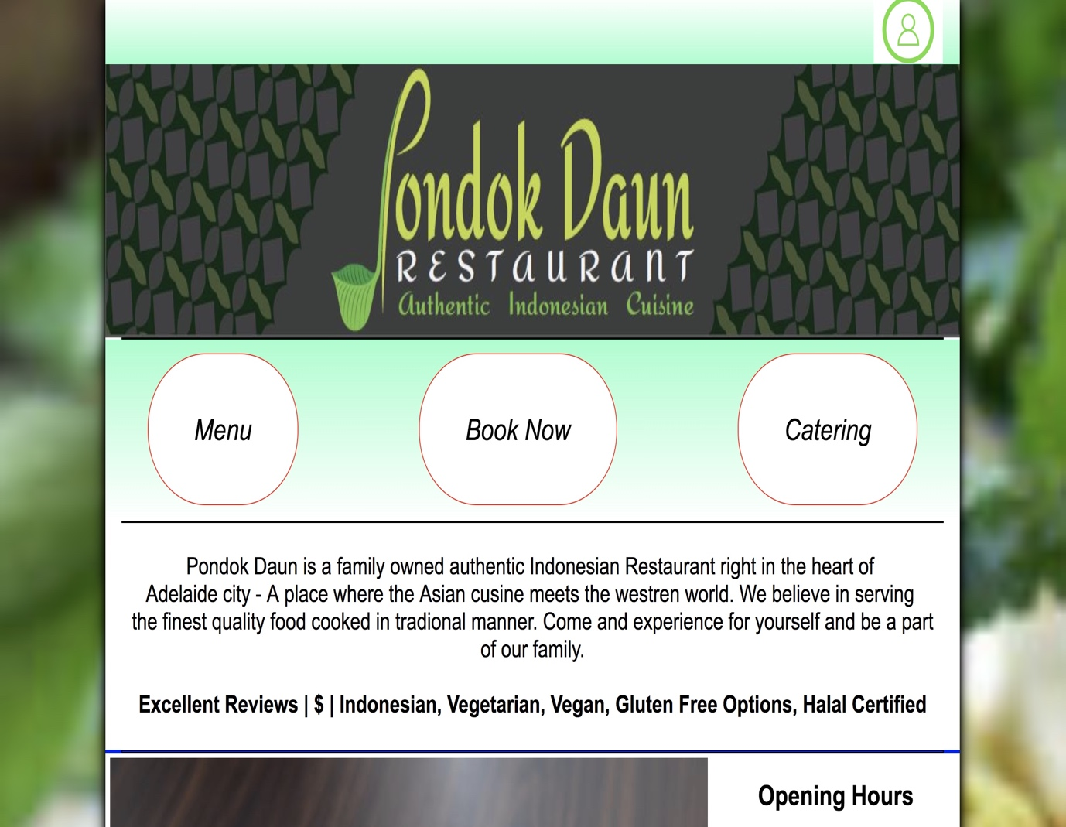

# **View the products.**

Customers can view the products and can choose from different range of food, drinks and entrees.

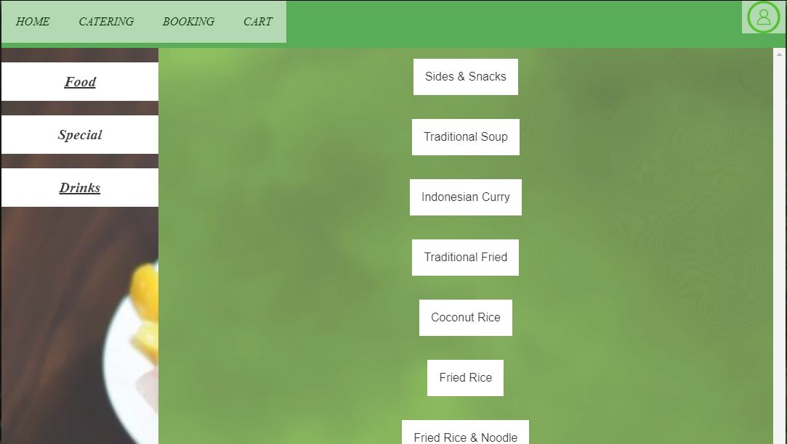

# **Sign up**

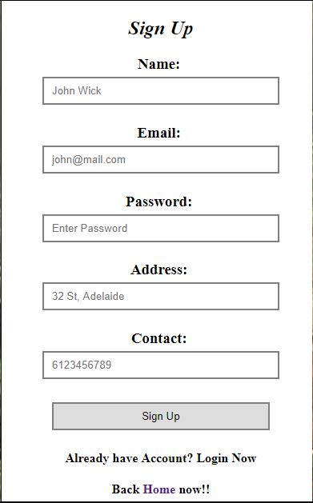

# **Login**

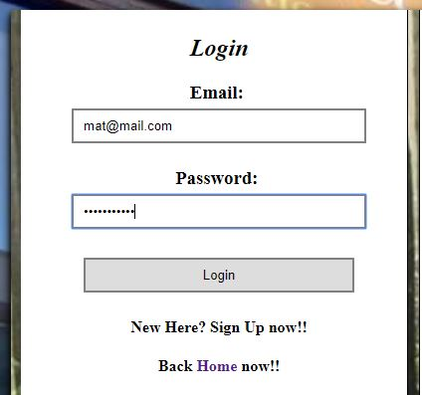

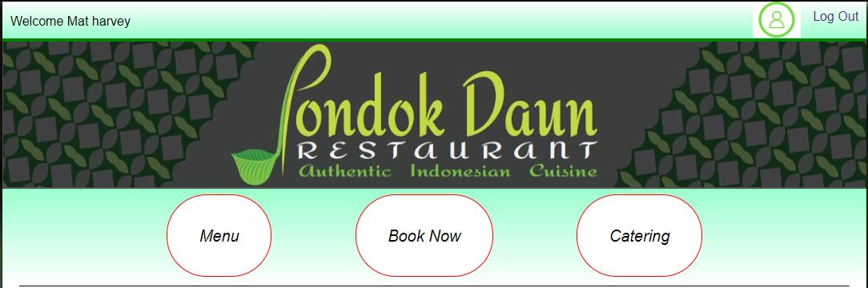

# **Order the food.**

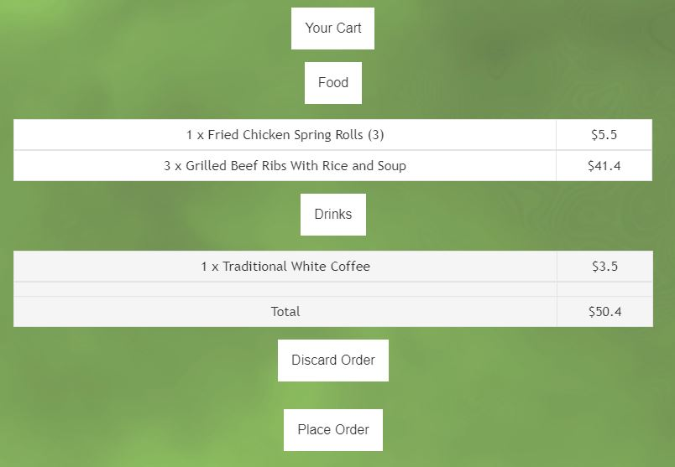

# **Book a table online.**

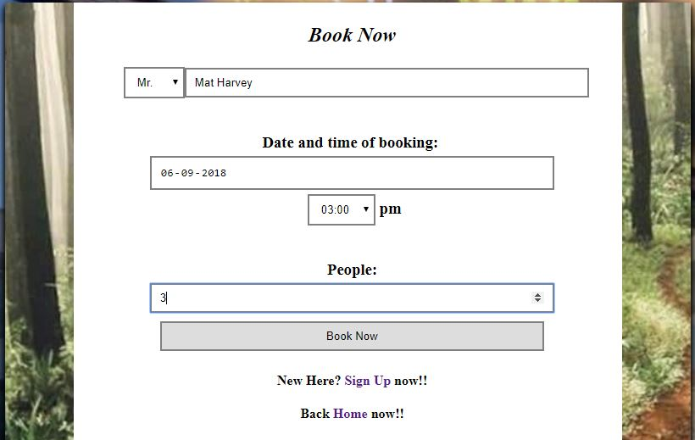

**7.View special items**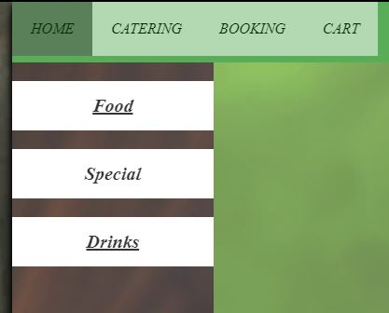

# **Book for catering**

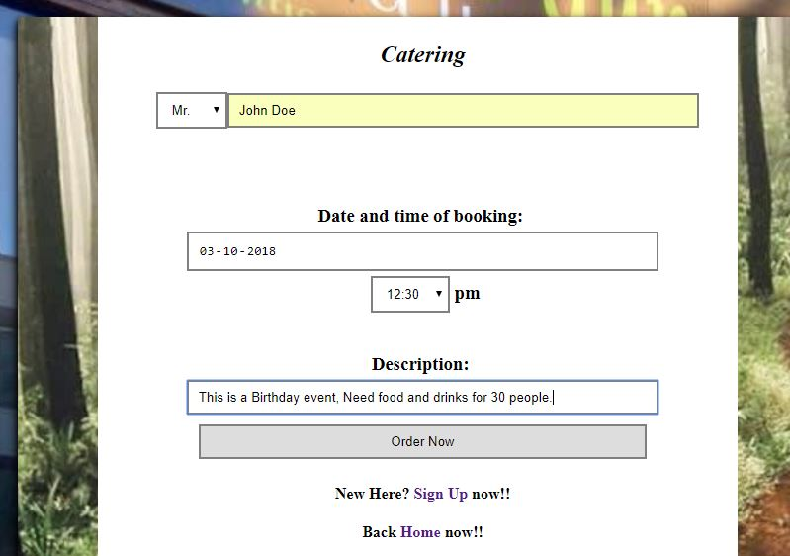

# **Feedback**



## **Admin login**

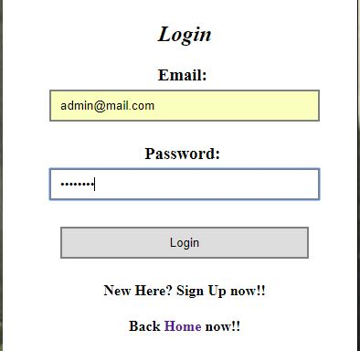

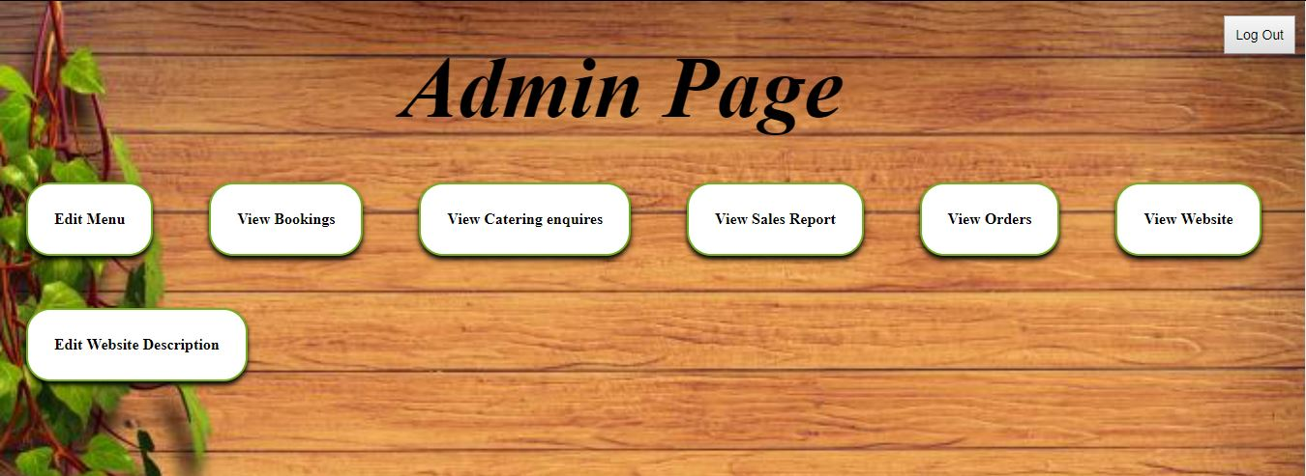

## **Admin view orders**

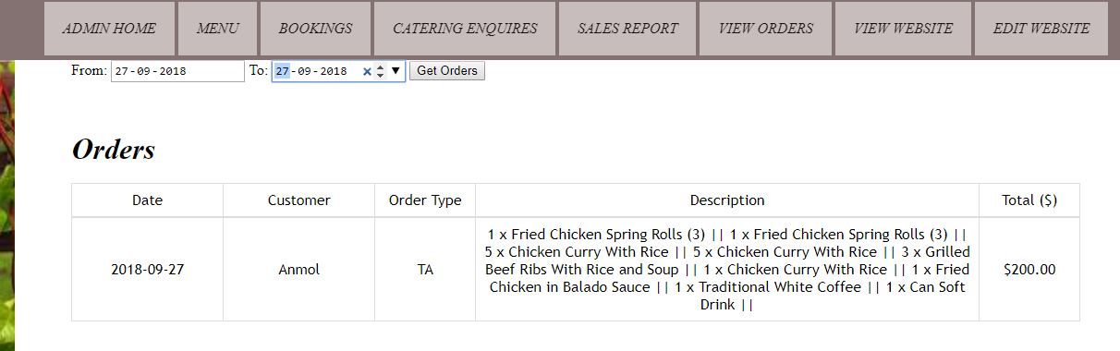

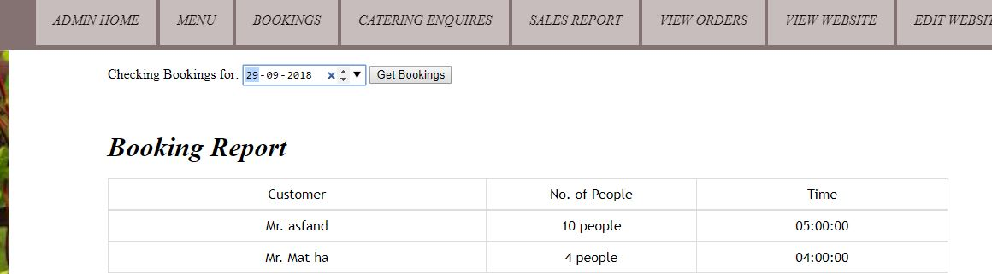

## **Daily sales report**

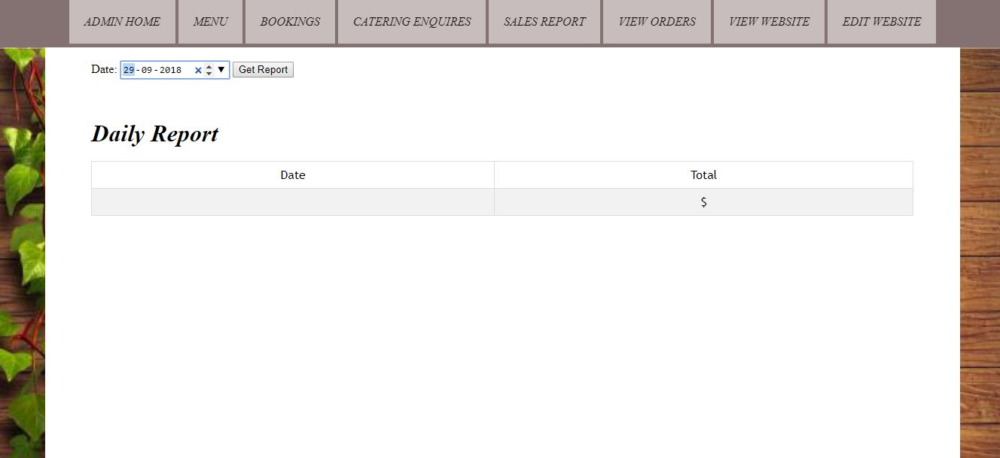

## **Sales of specific dates.**

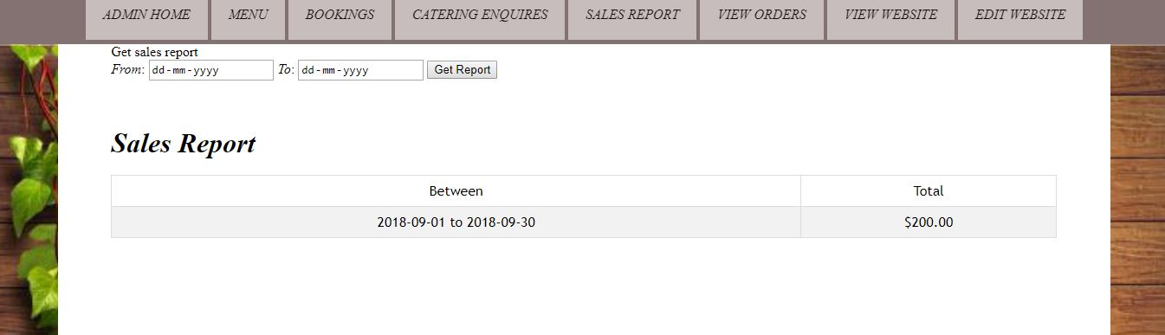

## **Monthly sales report**

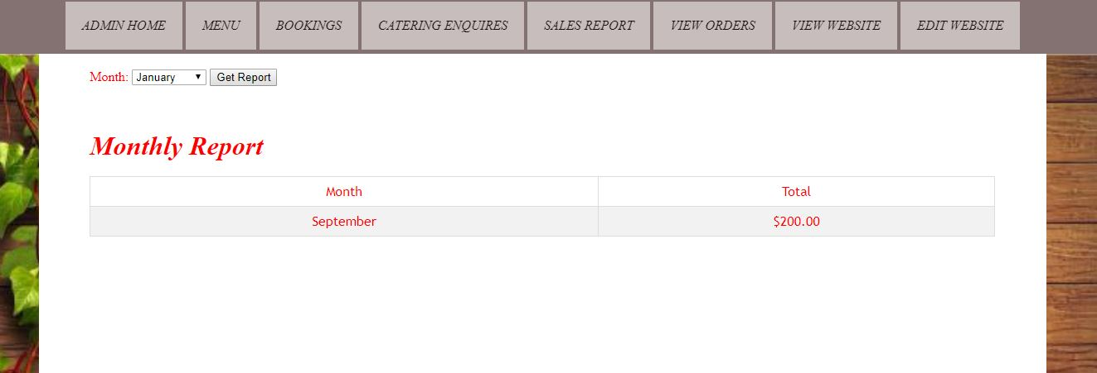

## **Edit menu**

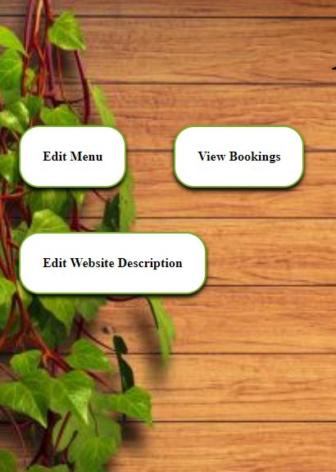

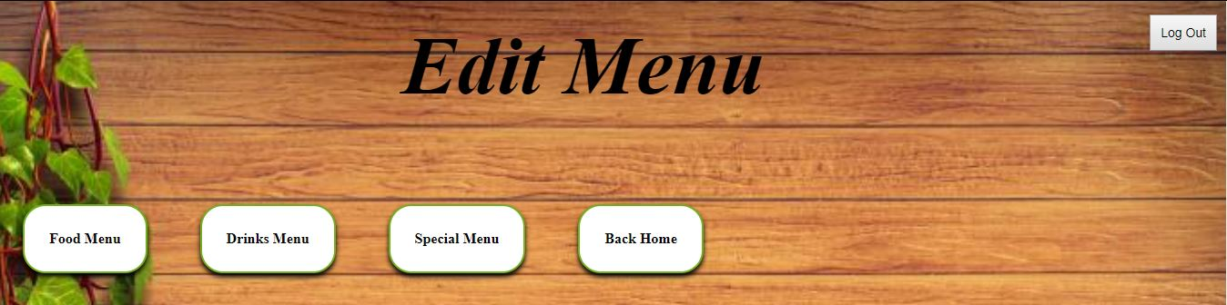

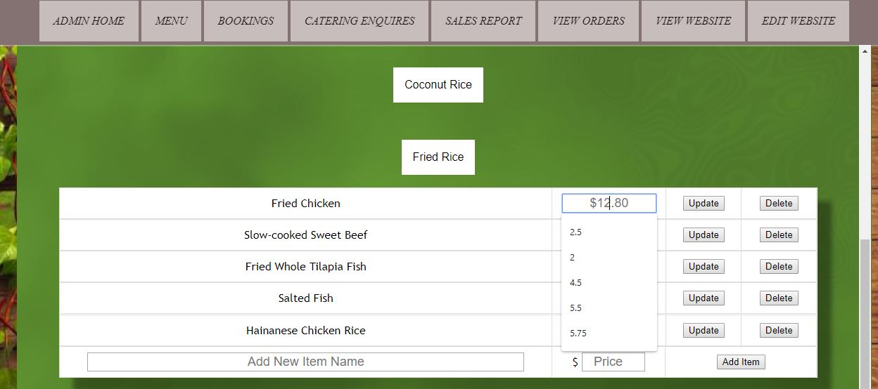

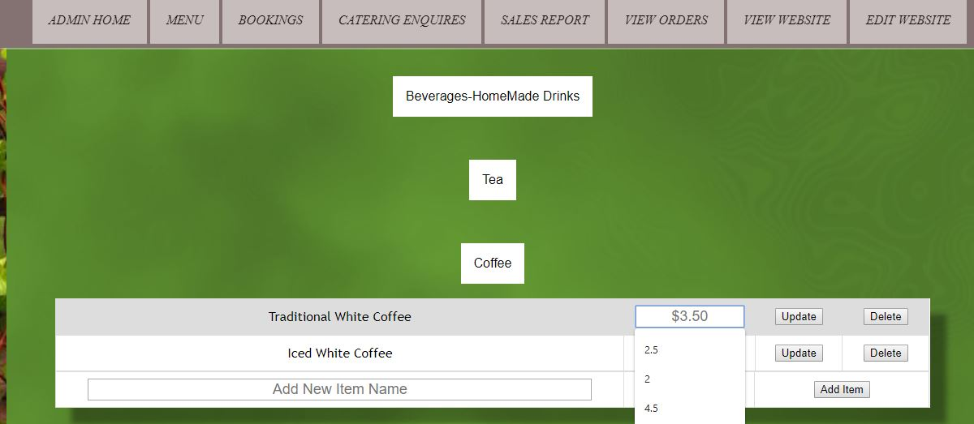

## **Catering orders**

